BSSH Malawi Training Fellowship
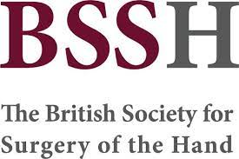
Are you interested in Hand Surgery? Are you interested in Global Health?
The BSSH is proud to launch the BSSH Malawi Training Fellowship, an exciting opportunity to be part of a team of volunteers developing the first dedicated hand surgery service in Malawi.
The fellowship will provide exposure to a breadth of hand surgery, and the unique pathologies and challenges faced when practising in low resource settings.
We are looking for trainees for a period of 4 weeks up to 12months
It is open to specialist trainees from either plastics or orthopaedics, at any stage of training.
Further information about the BSSH LION Hand Service is available at https://www.bssh.ac.uk/about/lion_hand_unit.aspx
Register your interest by clicking on the link below
https://www.surveymonkey.co.uk/r/9VSJS2C

